**INT305 Lab 14 Query**

1. Download Lab14_Query.zip and unzip the file
2. Open a terminal and change directory to the folder “Lab14_Query” and run “npm install”

cd Lab14_Query

npm install

1. Open VS Code, the file structure of Lab 14 as follows:

1. Copy your init.js from Lab 12 and paste it in src/firebase/init.js

1. Open src/App.vue, the source code is shown below:

You can add more queries using <RouterLink> with dynamic route matching with Params as “/query/:id”.

1. The route path /query will call the component QueryView.vue in the folder “src/views”

1. Open src/components/Documents.vue, the source code is shown below:

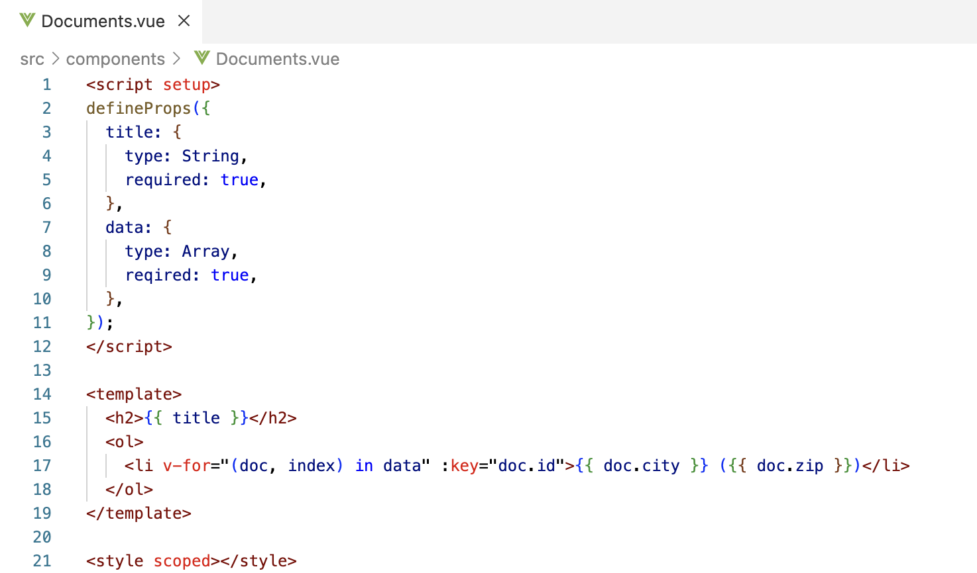

1. Run the project.

$ npm run dev

Output

Report 1

Report 2

1. Modify “src/App.vue” and “src/views/QueryView.vue” in order to retrieve data for the following queries: (Capture your output and Query source code for each report)
   1. [Report 3] List zips in DC with population > 40000.
   2. [Report 4] List zips in NY or in DC with population> 60000.
   3. [Report 5] List zips in DC or cities with population > 100000.
   4. [Report 6] List zips in DC and sort the data by population.
   5. [Report 7] List zips latitude between 71 and 73.
2. To submit your work:
   1. Copy the INT305_Lab14_Query.docx to the folder “Lab14_Query”.
   2. Remove the folder “node_modules”
   3. Rename the Lab14_Query to xxxxxxxxxxx
   4. Compress it as xxxxxxxxxxx.zip.
   5. Upload the zip file to LEB2.